**SMART STAR EXAMINATIONS BOARD**

**END OF TERM ONE EXAMINATION - 2024**

**HEALTH HABITS**

**MIDDLE CLASS**

My name is…………………………………………..

1. **Match the same pictures.**

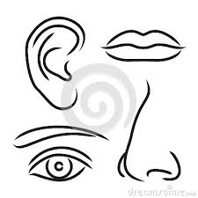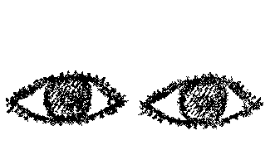

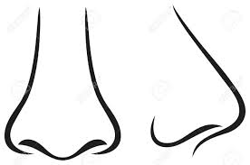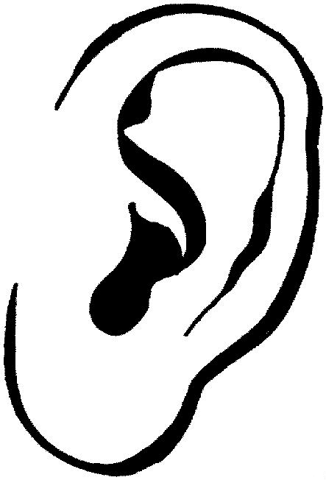









1. 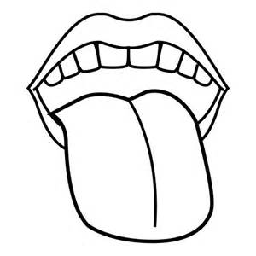**Shade body parts.**

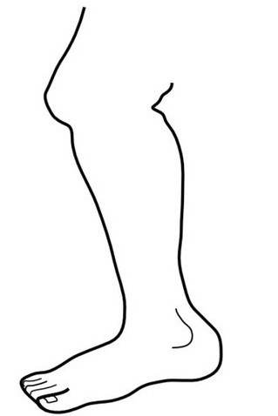

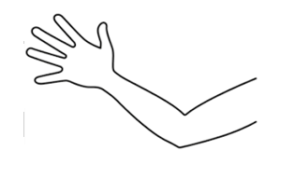

1. **Read and draw.**

**eyes**

**nose**

**mouth**

1. **Copy the same.**

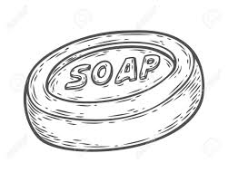

**Soap _______ ______**

**sponge_______ _______**

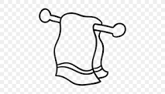

**towel______ _______**

1. **Circle the given word.**

mouth

mouthhhh

moon

eye

eye

egg

leg

leaf

leg

1. **Oral.**

**- Show me your head.**

**- how many legs do you have?**

**END**